**Selenium-Jenkins Integration**

**Step 1- Open your web browser and then Navigate to Below URL**  
<https://jenkins.io/download/>  this is the official website of Jenkins.

Click on **“windows”.**

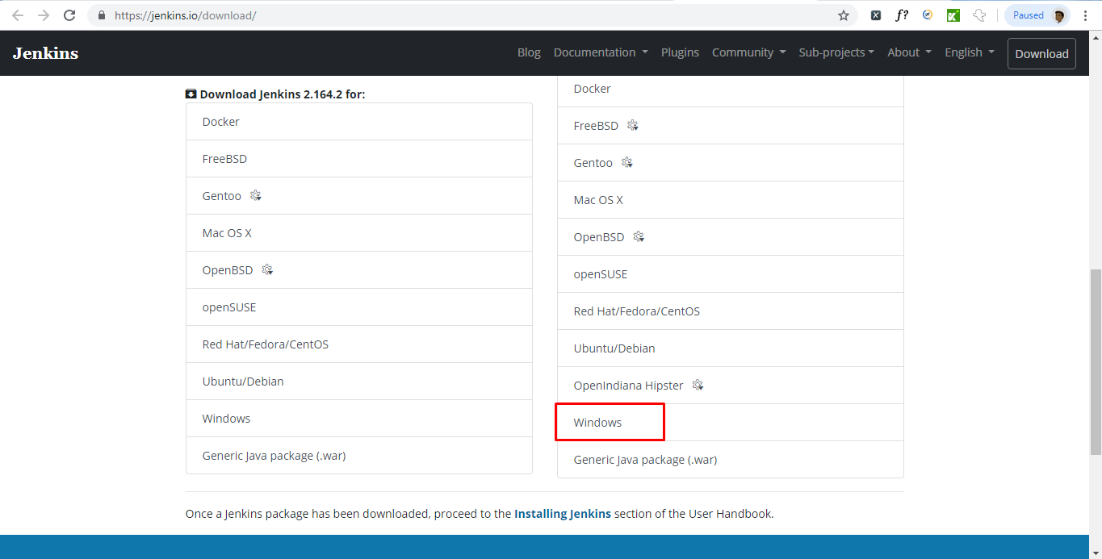

Jenkins jar file will downloaded directly.

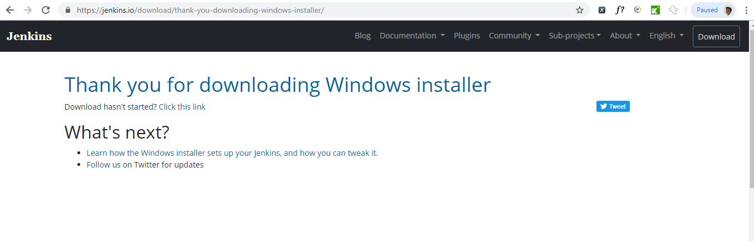

**Step 2) Unzip Jenkins to specified folder. Run exe file.**

**Step 3) You would be able to see success screen once execute the command.**

**Step 4) Navigate to the url in your browser http://localhost:8080, sometimes it may take up to 3 minutes to open the page, so have patience if you get no page/ error page.**

**Step 5) Navigate to the highlighted path in your browser, and copy the password.**

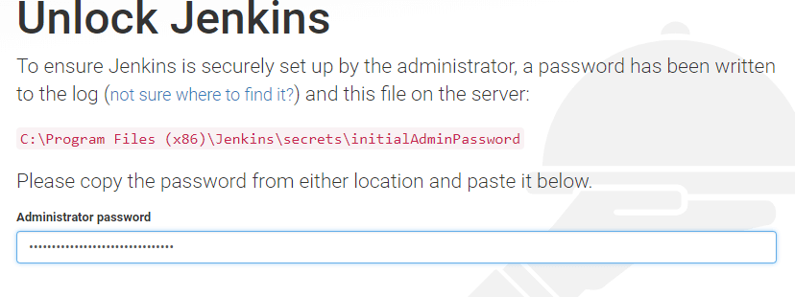

**Step 6) Install / select plugins based on your need, you can install plugins after installation of jenkins as well.**

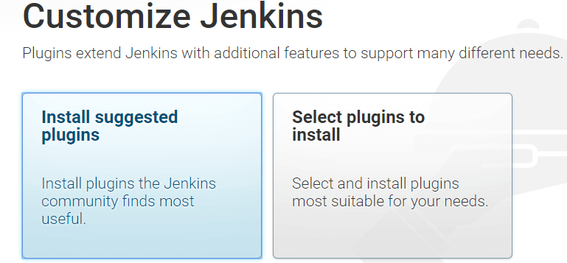

**Step 7) You may need to wait for 10-15 mins for completion of installation of plugins.**

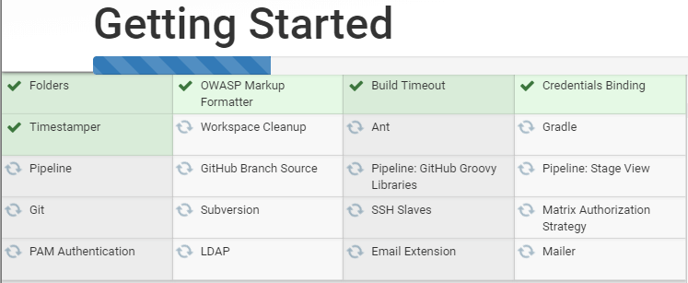

**Step 8) Fill the use details and continue**

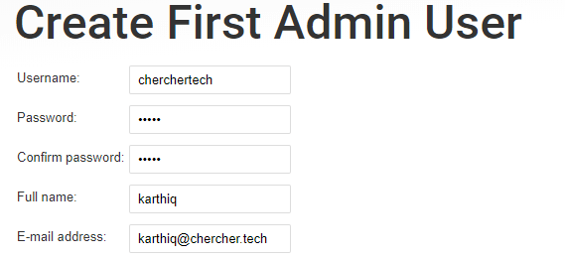

**Step 9) Click on start jenkins button**

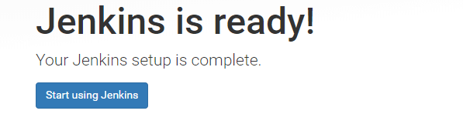

**Step 10) If you reached below page then you installation is successful.**

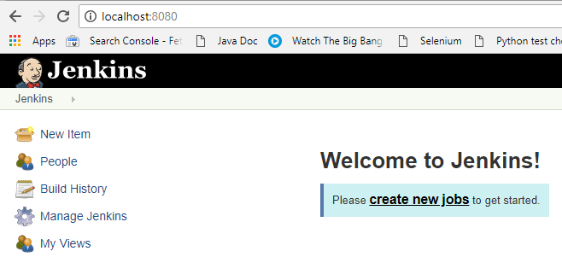

**Setup Jenkins Job**

**Step 1) Open jenkins and select 'New Item'**

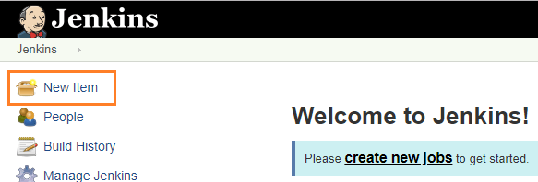

**Step 2) Enter the Job name, and Select Free Style project and click ok button.**

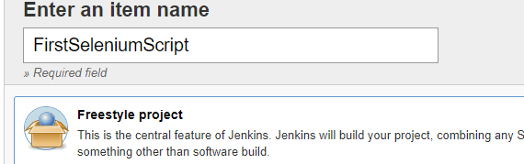

**Step 3) Select Custom workspace under General section and provide the project folder details.**

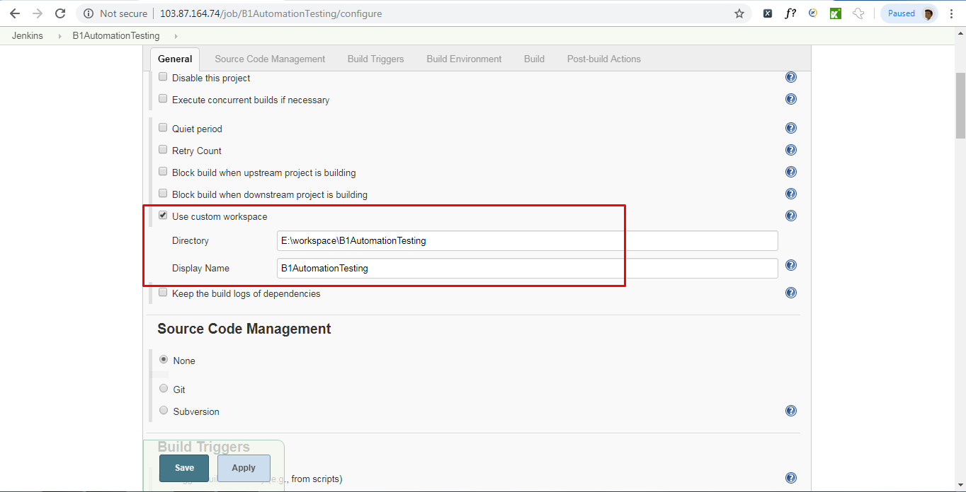

**Step 4) Click Save button, jenkins now will open the home page.  
  
Step 5) Click on Manage Jenkins**

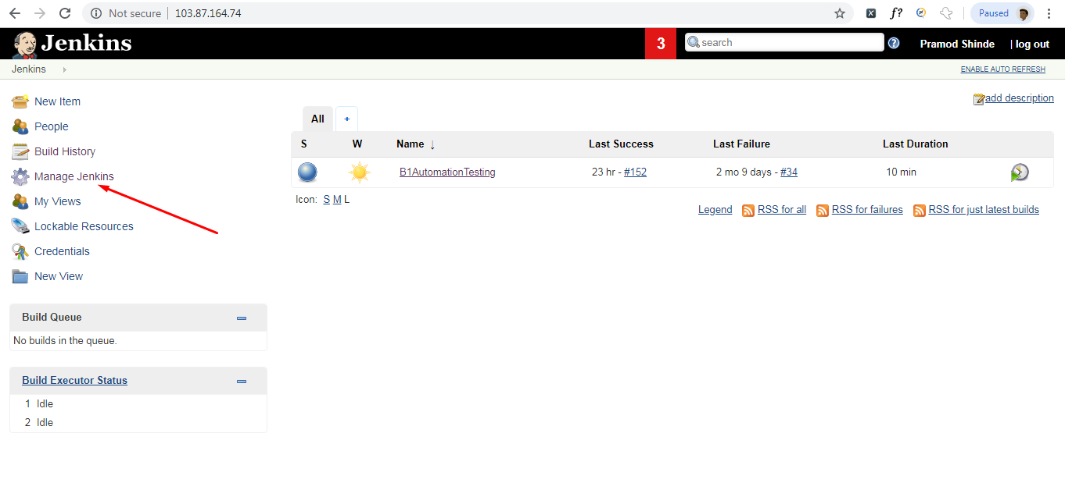

**Step 6) Click on Configure System**

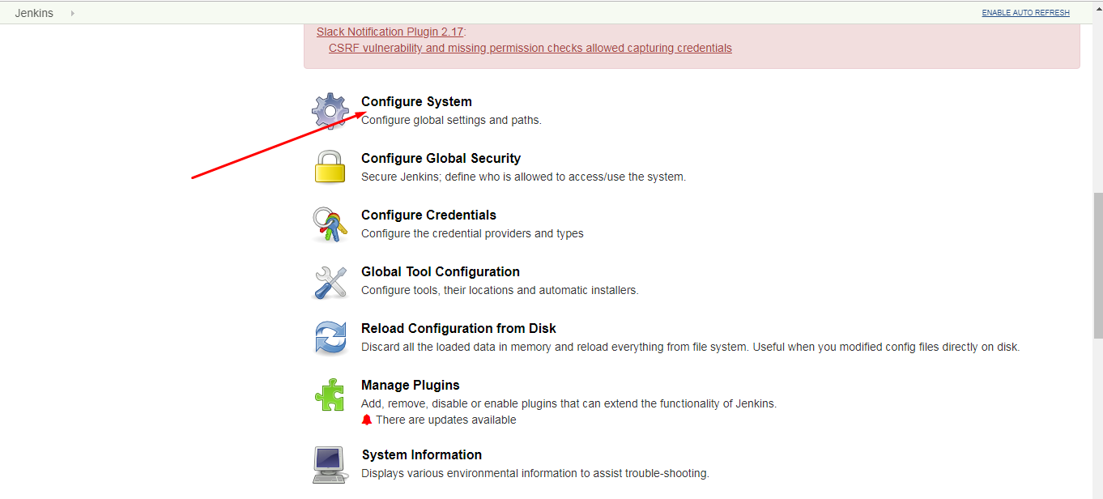

**Step 7) Go to Jenkins Location section and enter following details –**

Jenkins URL: <http://103.87.164.74/>

This IP address must be your system IP address where you kept your project.

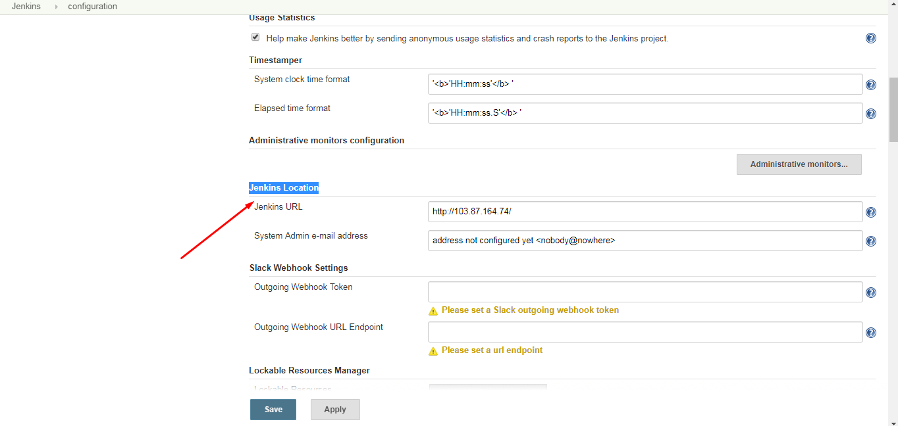

**Step 8) Go to Dashboard page and click on Project**

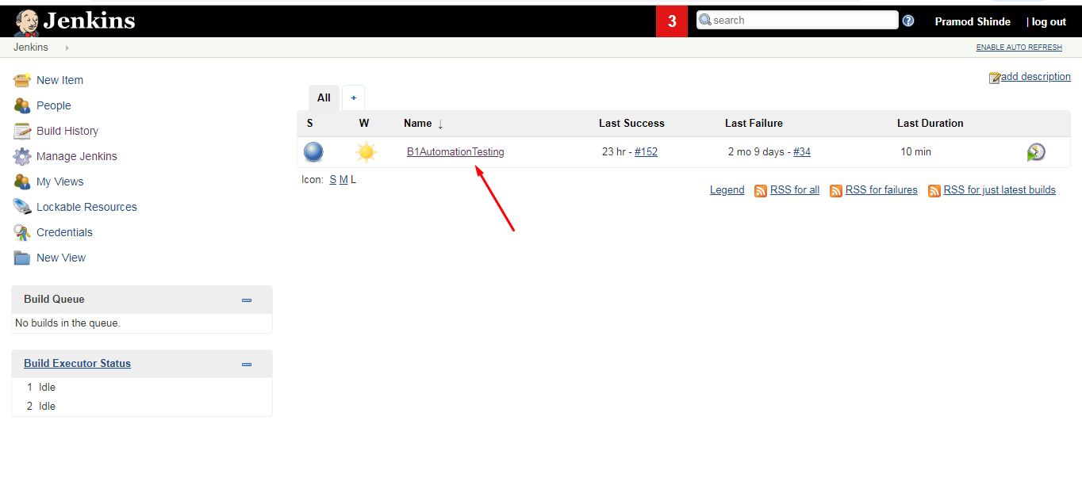

**Step 9) Go to Project Detail page and click on “Configure” link at Left Side of the page**

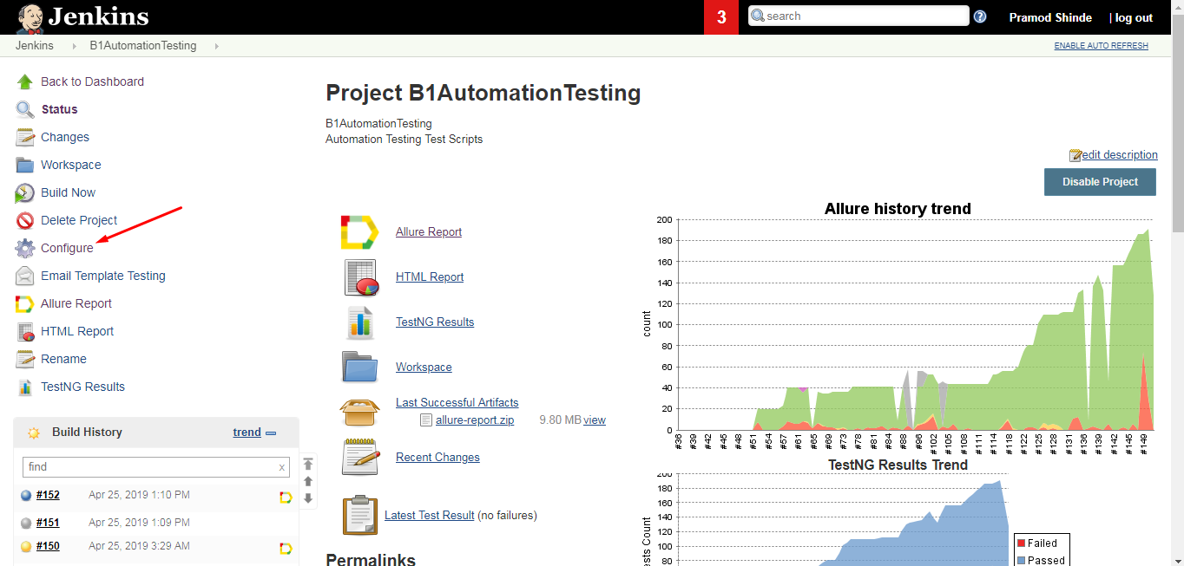

**Step 10) Go to “General” tab and enter following details:-**

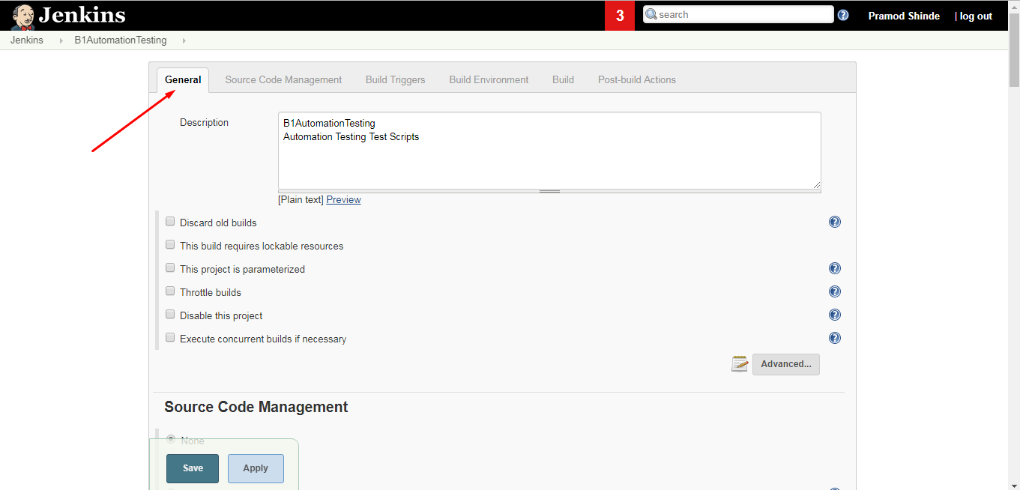

**Step 11) Go to “Build” tab**

* **Click on Add build Step drop down and Select “Invoke top-level Maven targets”**
* **Maven Version – Maven 3.0.6**
* **Goals – clean test (This should be same name as given in Maven Build)**
* **POM - E:\workspace\B1AutomationTesting\pom.xml**

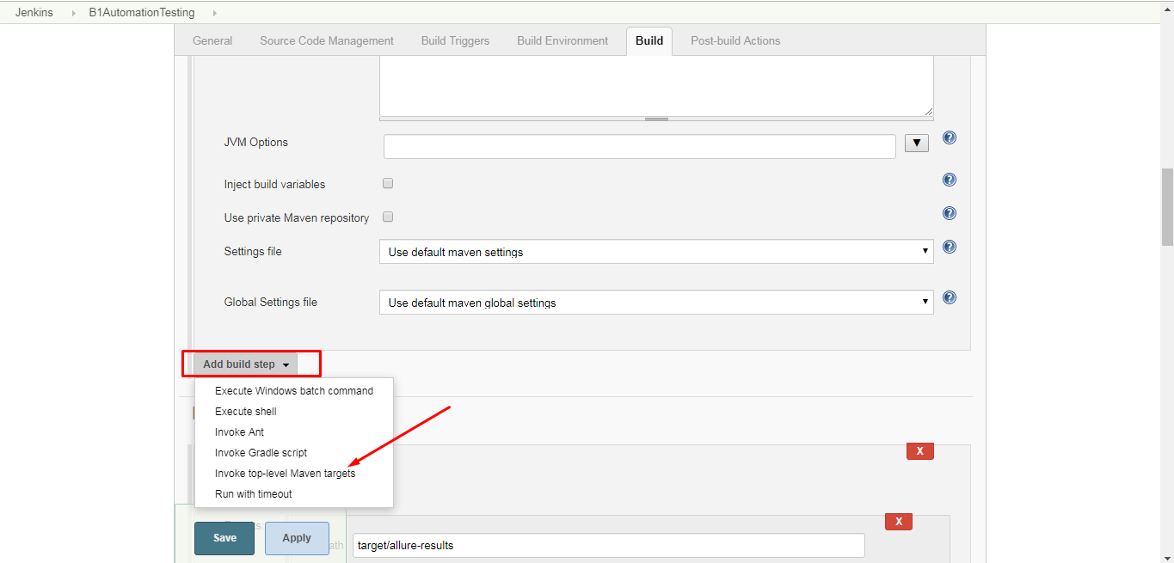

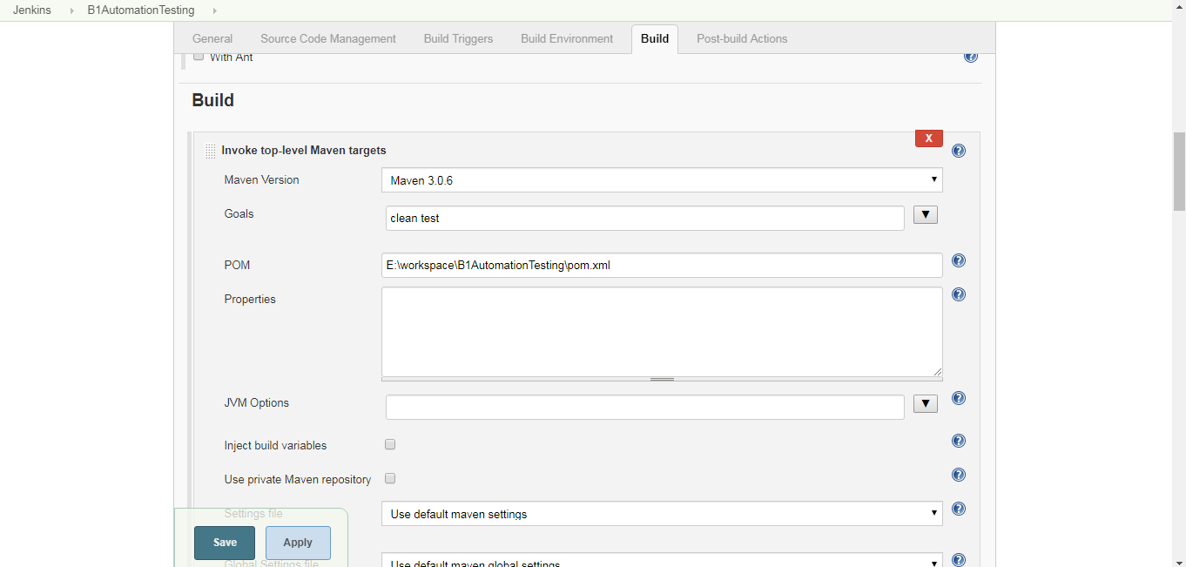

**Click on Save and Apply buttons.**

**Step 12) Click on Project and click on ‘Build Now’ link.**

**Execution will get start.**

**Setup TestNG Report Integration in Jenkins**

**Step 1) Go to Jenkins > Manage Jenkins > Manage Plugins page.**

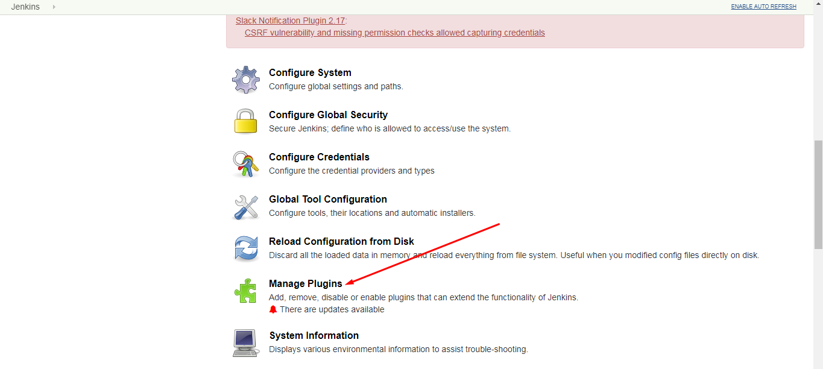

**Step 2) On Manage Plugins page, go to ‘Available’ table and search for “TestNG Results Plugin” and install it. Click the ‘Install without restart’ button.**

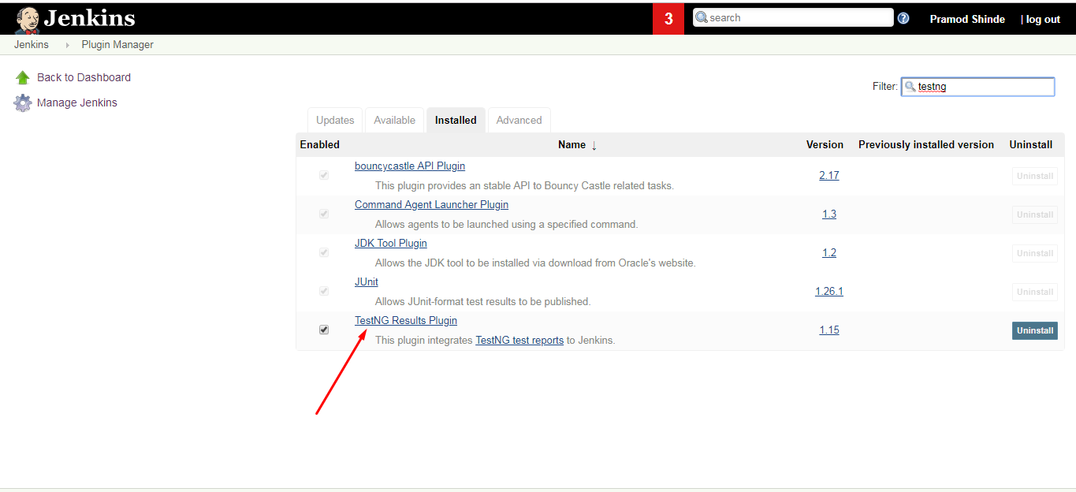

**Step 3) Go to Project Detail page and click on “Configure” link at Left Side of the page**

**Step 4) Click on “Add post-build action” dropdown and select “Publish TestNG Results”**

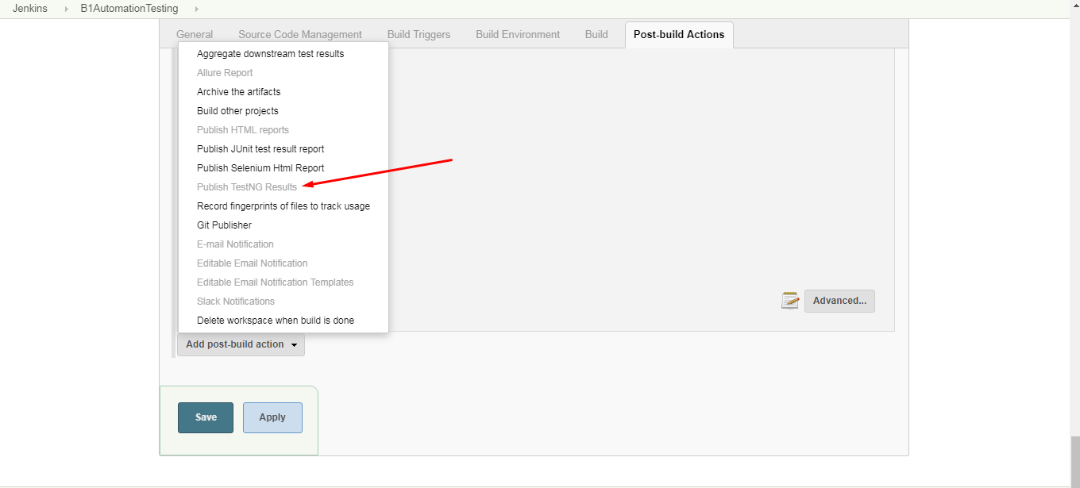

**Step 5) Now go to Publish TestNG Results page.**

**Enter following value:**

**TestNG XML report pattern – **/testng-results.xml**

**Step 6) Click on Save and Apply button.**

**Step 7) Run the Jenkins Build and it will displays ‘TestNG Results’ on Project details page.**

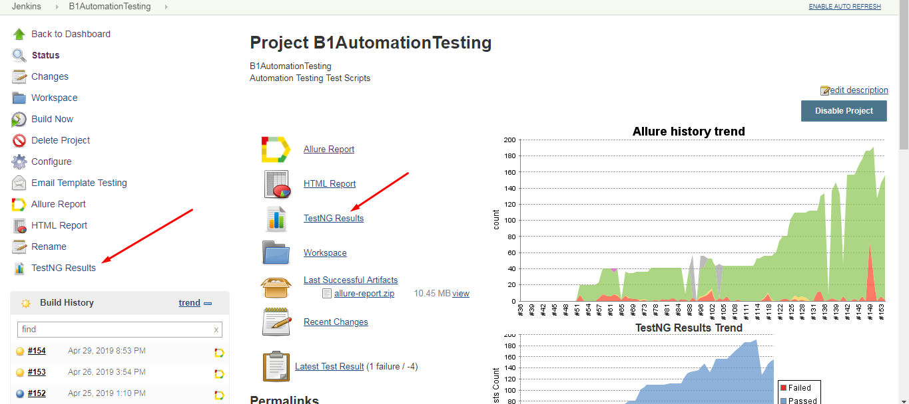

**Setup Email Integration in Jenkins**

**Step 1) Open Jenkins using the following URL: http://localhost:8080/ on any browser.**

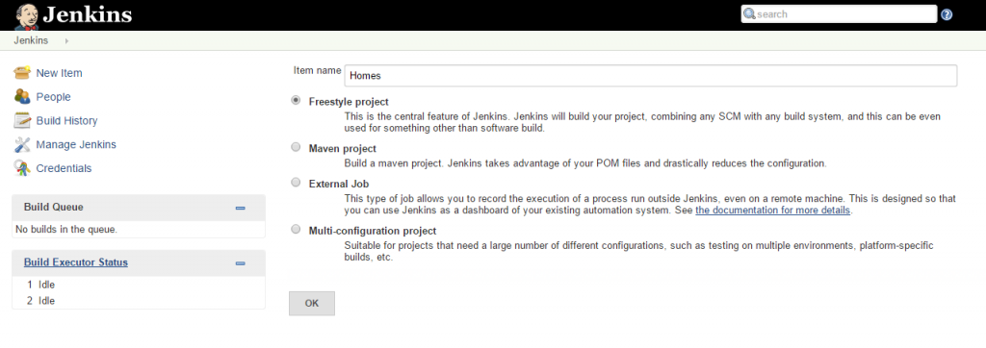

**Step 2) Click the ‘Manage Jenkins’ menu option displayed at the right side of the screen. You will be redirected to the ‘Manage Jenkins’ page, where you need to select the ‘Manage Plugin’ option.**

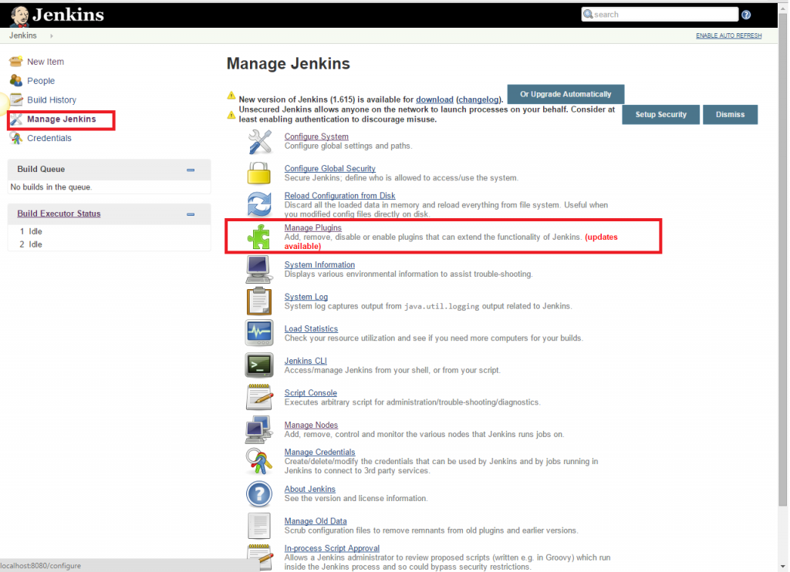

**Step 3) Click the ‘Available’ tab present at the top of the ‘Manage Plugin’ page.**

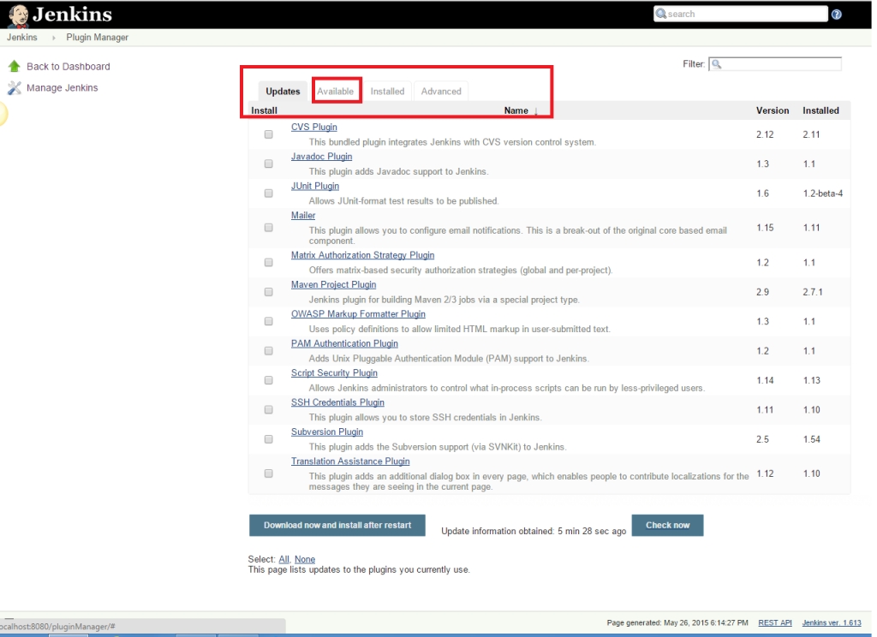

**Step 4) Start typing ‘Notification’ in the ‘Filter’ field displayed at the top-right side of the ‘Manage Plugin’ page. Click the checkbox next to the ‘Email-ext plugin’ option. Click the ‘Install without restart’ button.**

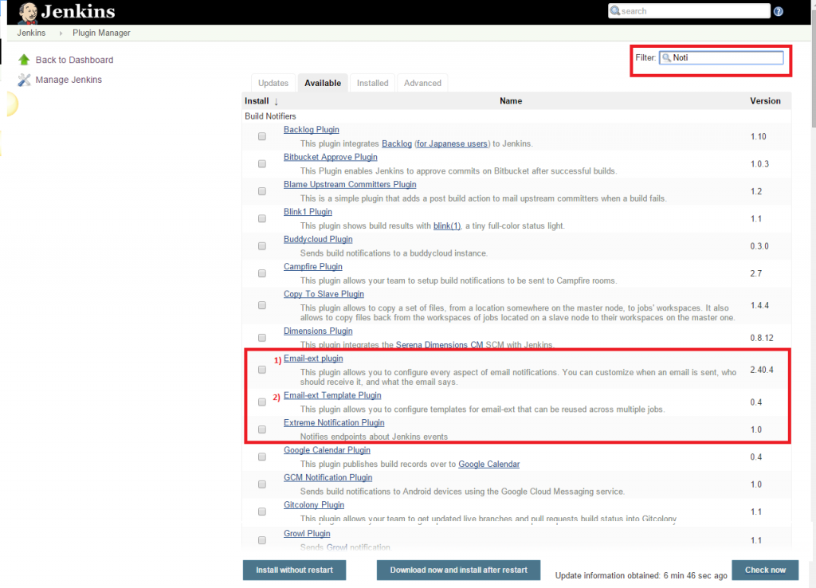

**Step 5) Now, click the checkbox next to the ‘Email-ext Template Plugin’ option. Click the ‘Install without restart’ button.**

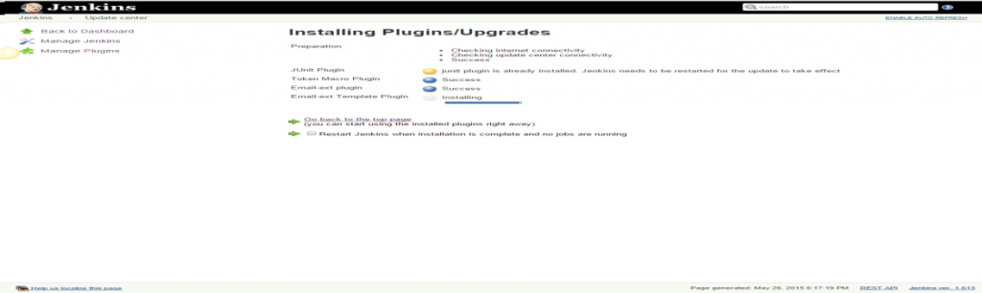

**Step 6) Go to the Jenkins home page and click the ‘Manage Jenkins’ menu option. Then, select the ‘Configure System’ option.**

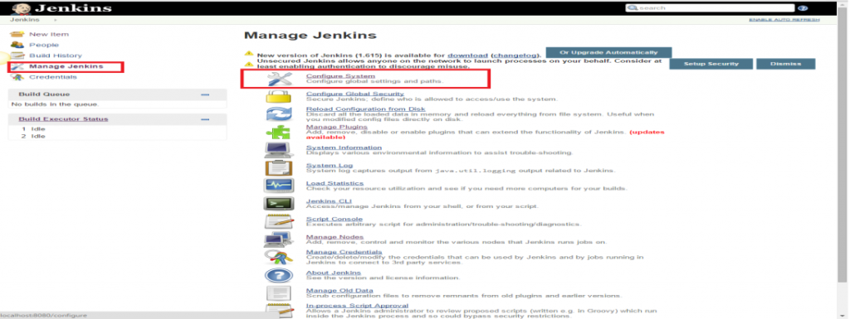

**Step 7) Enter the SMTP server name under ‘Email Notification’. Click the ‘Advanced’ button and then click the checkbox next to the ‘Use SMTP Authentication’ option. Now, set the following fields.**

* + **SMTP server name** : smtp.gmail.com
  + **User name**: user_email_id@gmail.com
  + **Password**: 123456
  + **Use SSL**: Checked
  + **SMTP Port**: 456

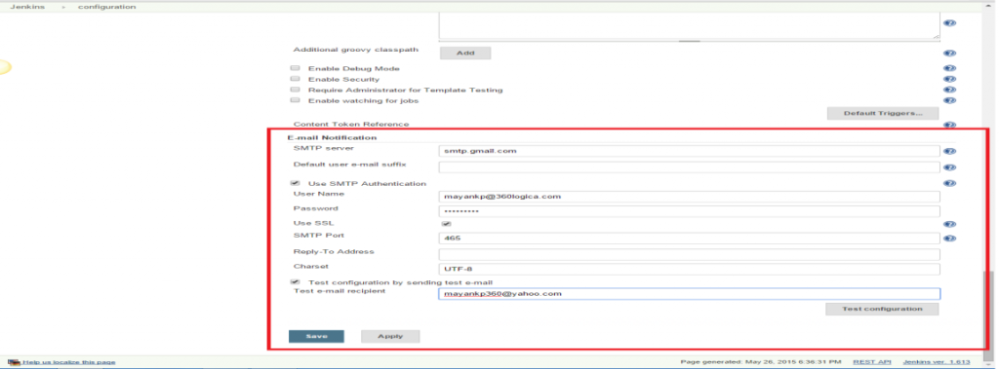

**Step 8) Check the email notification functionality by clicking the checkbox next to the ‘Test configuration by sending Test e-mail recipient’ option. Enter a valid email id and click the ‘Test configuration’ button to check whether the email id is valid or not.**

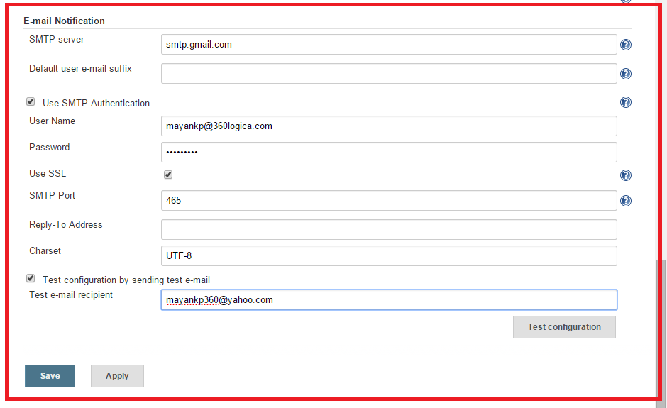

**Step 9) Go to Project Detail page and click on “Configure” link at Left Side of the page**

**Step 2) Click on “Add post-build action” dropdown and select “E-mail Notification” and “Editable Email Notification” option.**

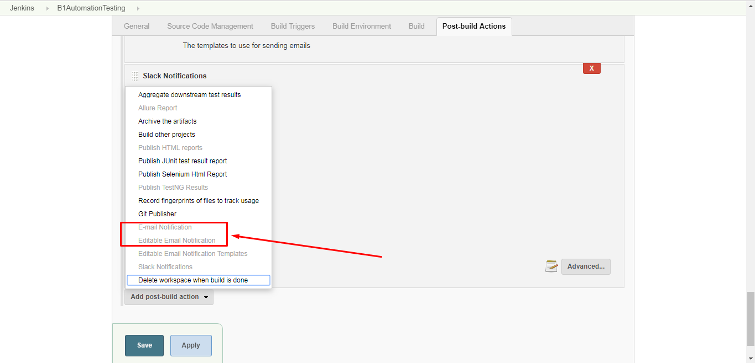

**Step 3) Go to E-mail Notification and enter following details.**

* **Recipients – enter email address**
* **Select checkbox of “Send e-mail for every unstable build”**

**Click on Save and Apply button.**

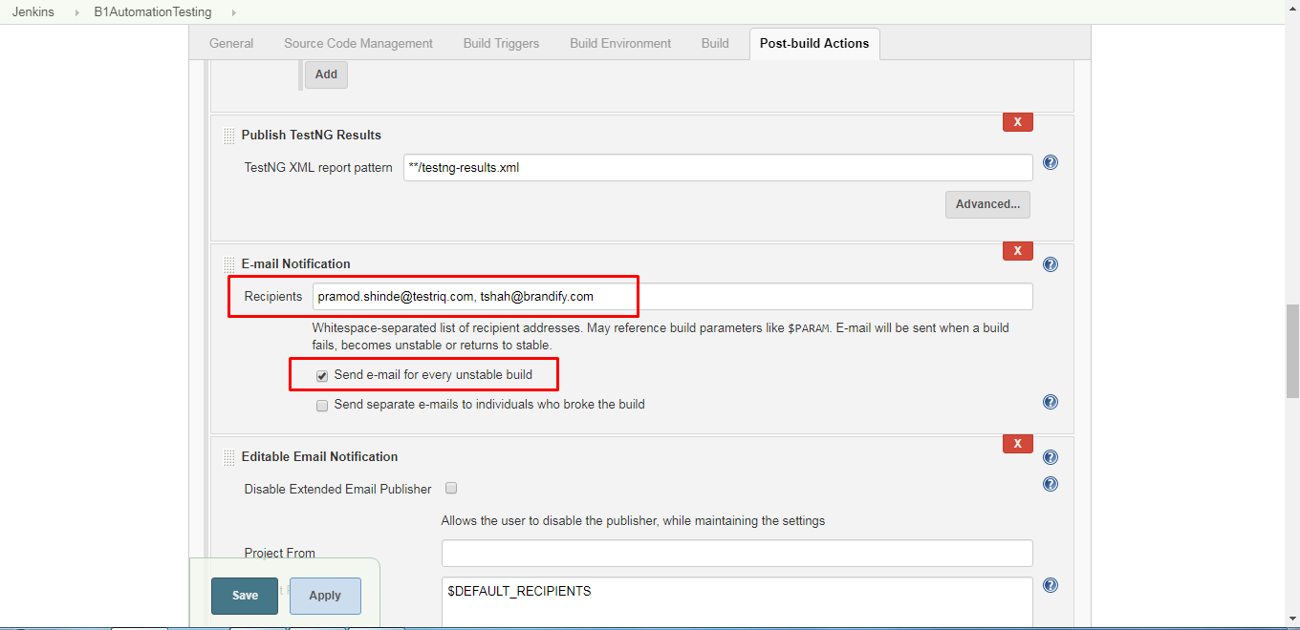

**Step 4) Go to Editable Email Notification and enter following details.**

* **Project Recipient List - $DEFAULT_RECIPIENTS**
* **Project Reply-To List - $DEFAULT_REPLYTO**
* **Content Type – Default Content Type**
* **Default Subject - $DEFAULT_SUBJECT**
* **Default Content - $DEFAULT_CONTENT**
* **Pre-send Script - def reportPath = build.getWorkspace().child("test-output/emailable-report.html") msg.setContent(reportPath.readToString(), "text/html");**
* **Post-send Script - $DEFAULT_POSTSEND_SCRIPT**
* **Triggers – Select ‘Always’ option**
  + **Recipient List - pramod.shinde@testriq.com,** [**tshah@brandify.com**](mailto:tshah@brandify.com)
  + **Reply-To List -** [**pramod.shinde@testriq.com**](mailto:pramod.shinde@testriq.com)
  + **Content Type – HTML(text/html)**
  + **Subject - $PROJECT_DEFAULT_SUBJECT**
  + **Content - $PROJECT_DEFAULT_CONTENT**
  + **Attachments - test-output/emailable-report.html**
  + **Attach Build Log – Do Not Attach Build Log**

**Step 5) Click on Save and Apply button**

**When executed build in Jenkins, it will send email to mentioned Recipient address.**